Shy Panda

In this project you will make a dancing panda.

It’ll be a shy panda, that will get embarrassed and stop dancing if it sees you looking in through the window.

You’ll train it so that if you cover your eyes, it’ll recognise that you’re not looking and keep dancing.

The idea for this project came from Cassie Evans. You can see her version of it at   
https://codepen.io/cassie-codes/pen/jKaVqo

The panda artwork in this project was by Ed Moffatt from XMPT Games.

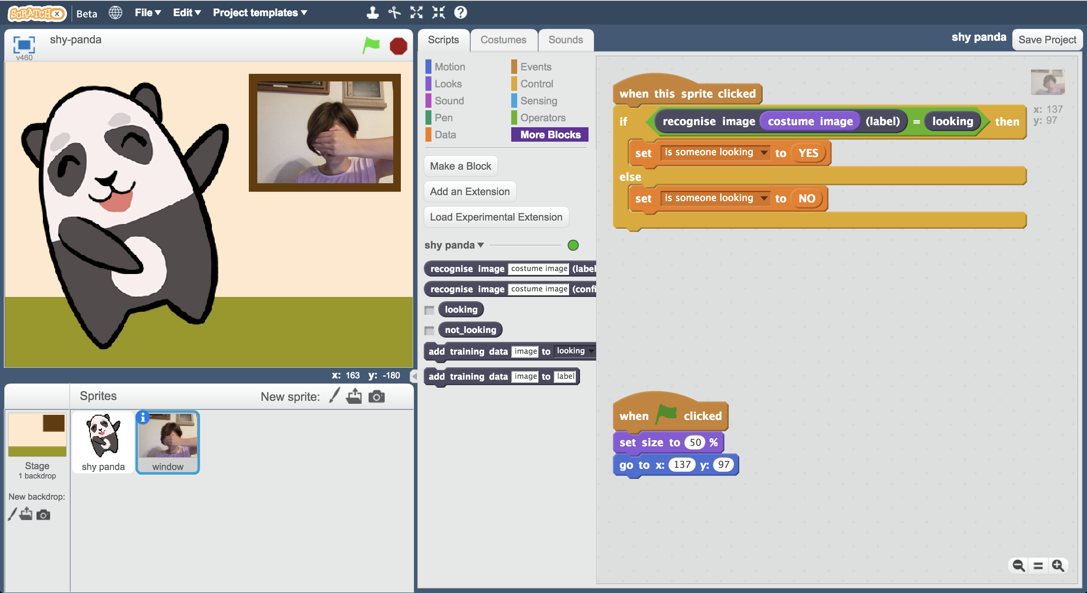

This project worksheet is licensed under a Creative Commons Attribution Non-Commercial Share-Alike License

http://creativecommons.org/licenses/by-nc-sa/4.0/

1. Go to <https://machinelearningforkids.co.uk/> in a web browser
2. Click on “**Get started**”
3. Click on “**Log In**” and type in your username and password  
   *If you don’t have a username, ask your teacher to create one for you.  
   If you can’t remember your password, ask your teacher to reset it for you.*
4. Click on “**Projects**” on the top menu bar
5. Click the **“+ Add a new project**” button.
6. Name your project “shy panda” and set it to learn how to recognise “**images**”. Click the “**Create**” button  
   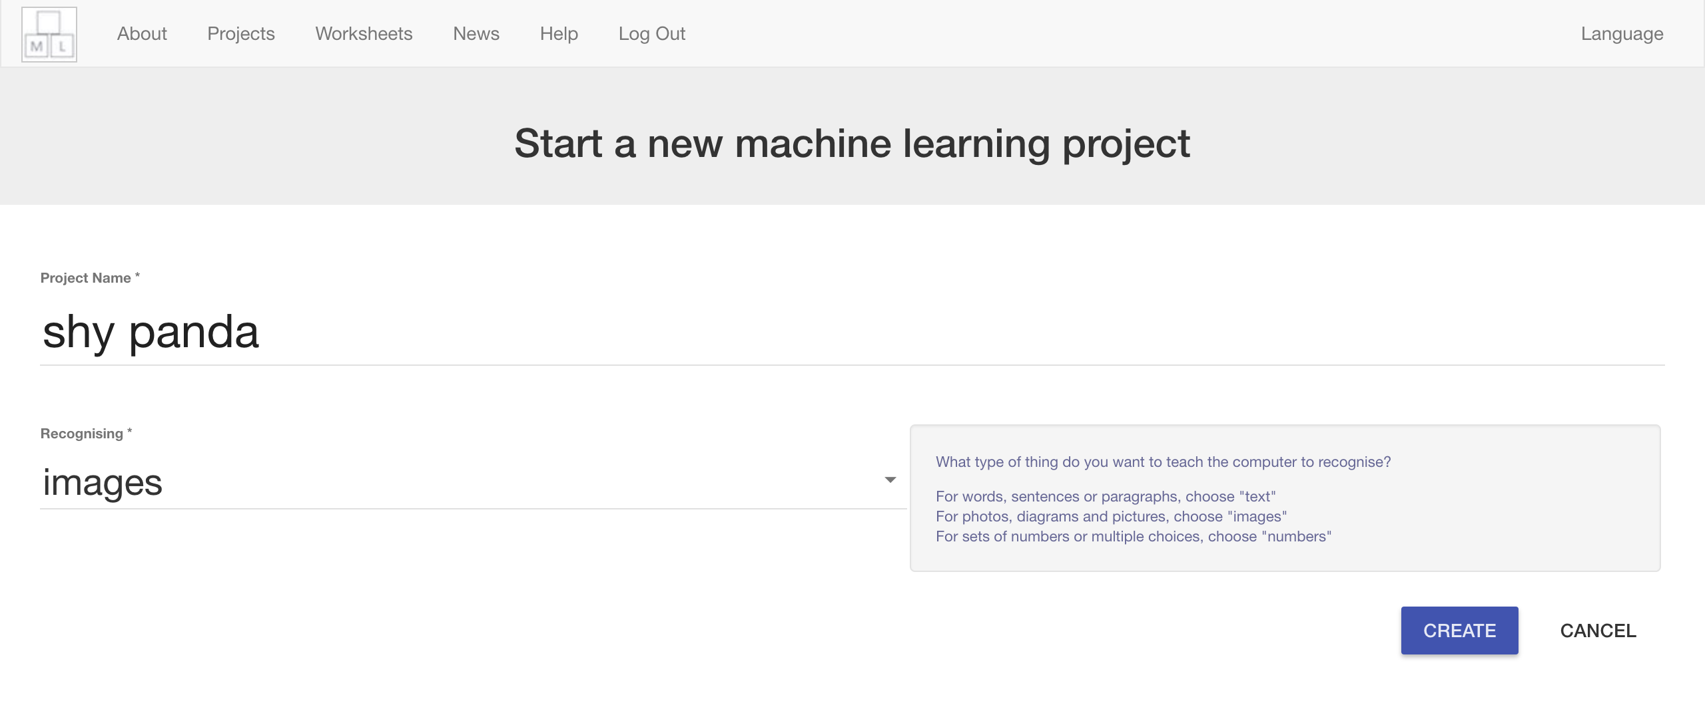
7. You should see “**shy panda**” in the list of your projects. Click on it.  
   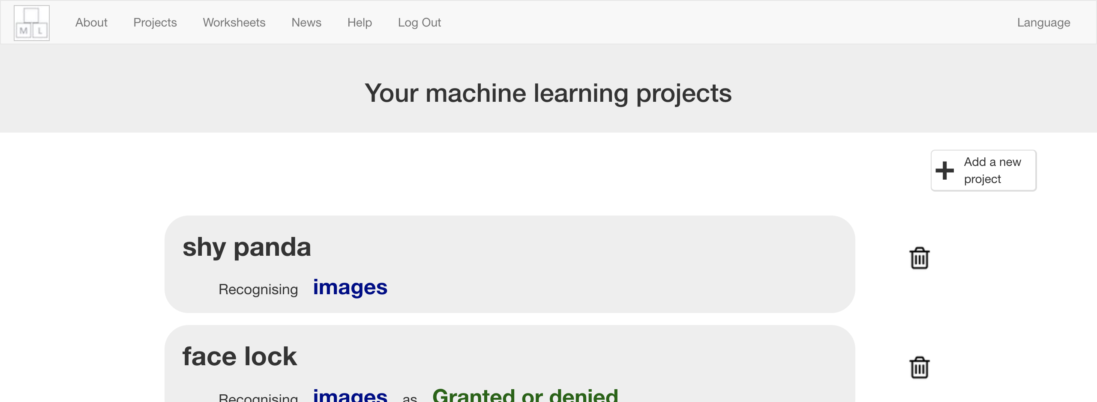
8. Click the **Train** button  
   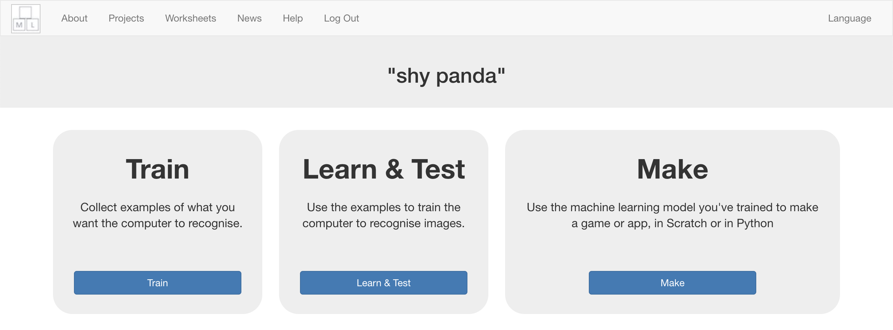
9. Click “**+ Add new label**”  
   
10. Type in “looking”, and press **Add**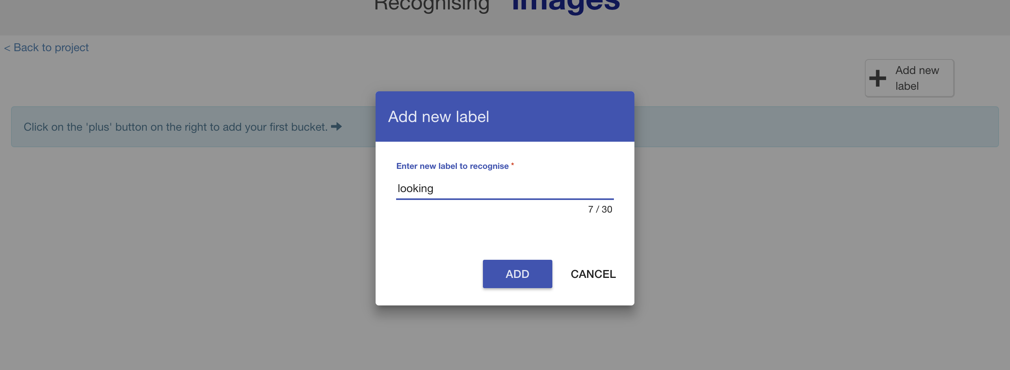
11. Do that again, but this time add “not looking”  
    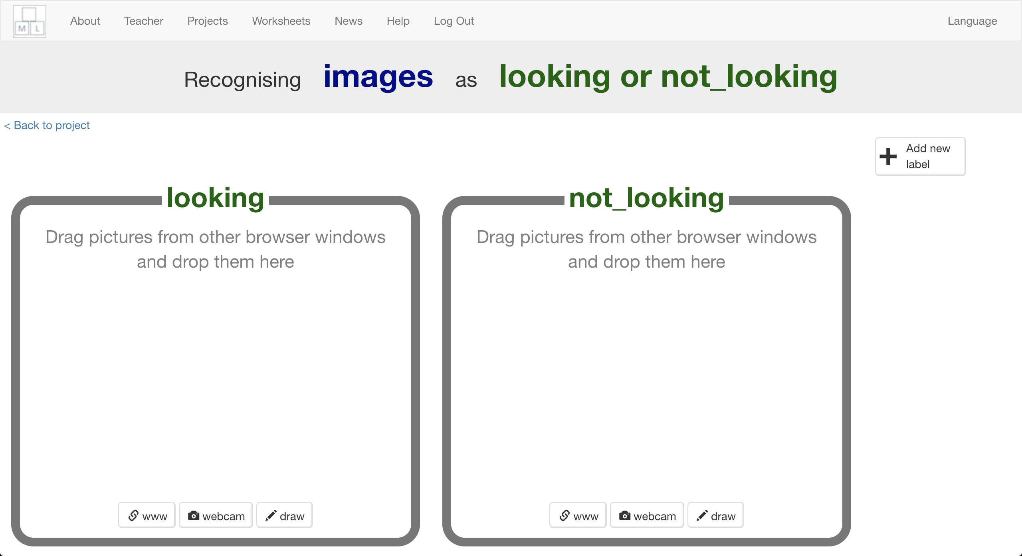
12. Click on the “**webcam**” button in the “not looking” bucket  
    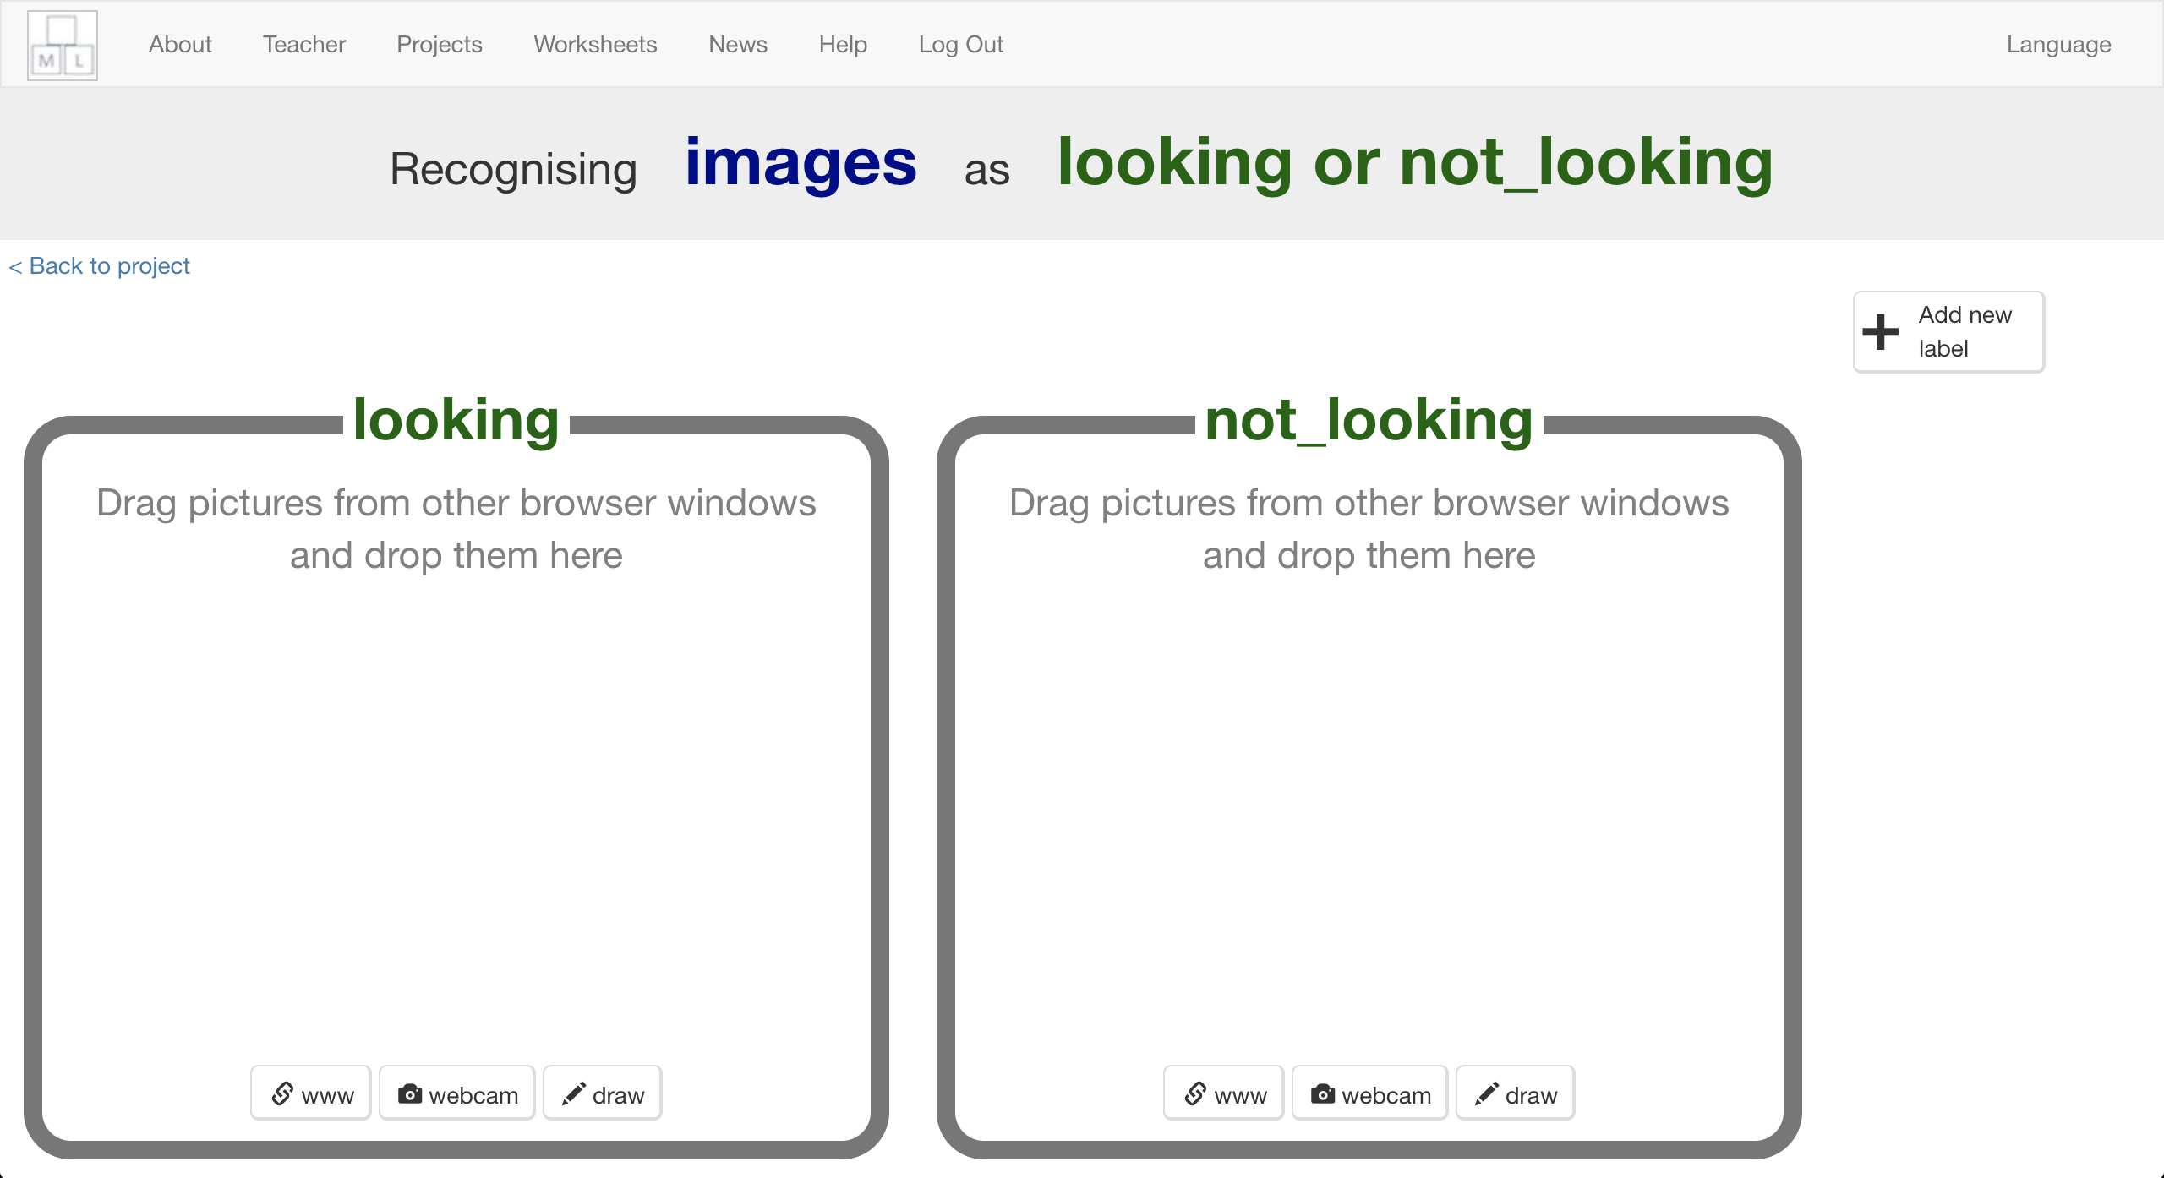
13. Cover your face with your hands, and take a photo   
    *It might be easier if you have a partner to click the “Add” button for you!*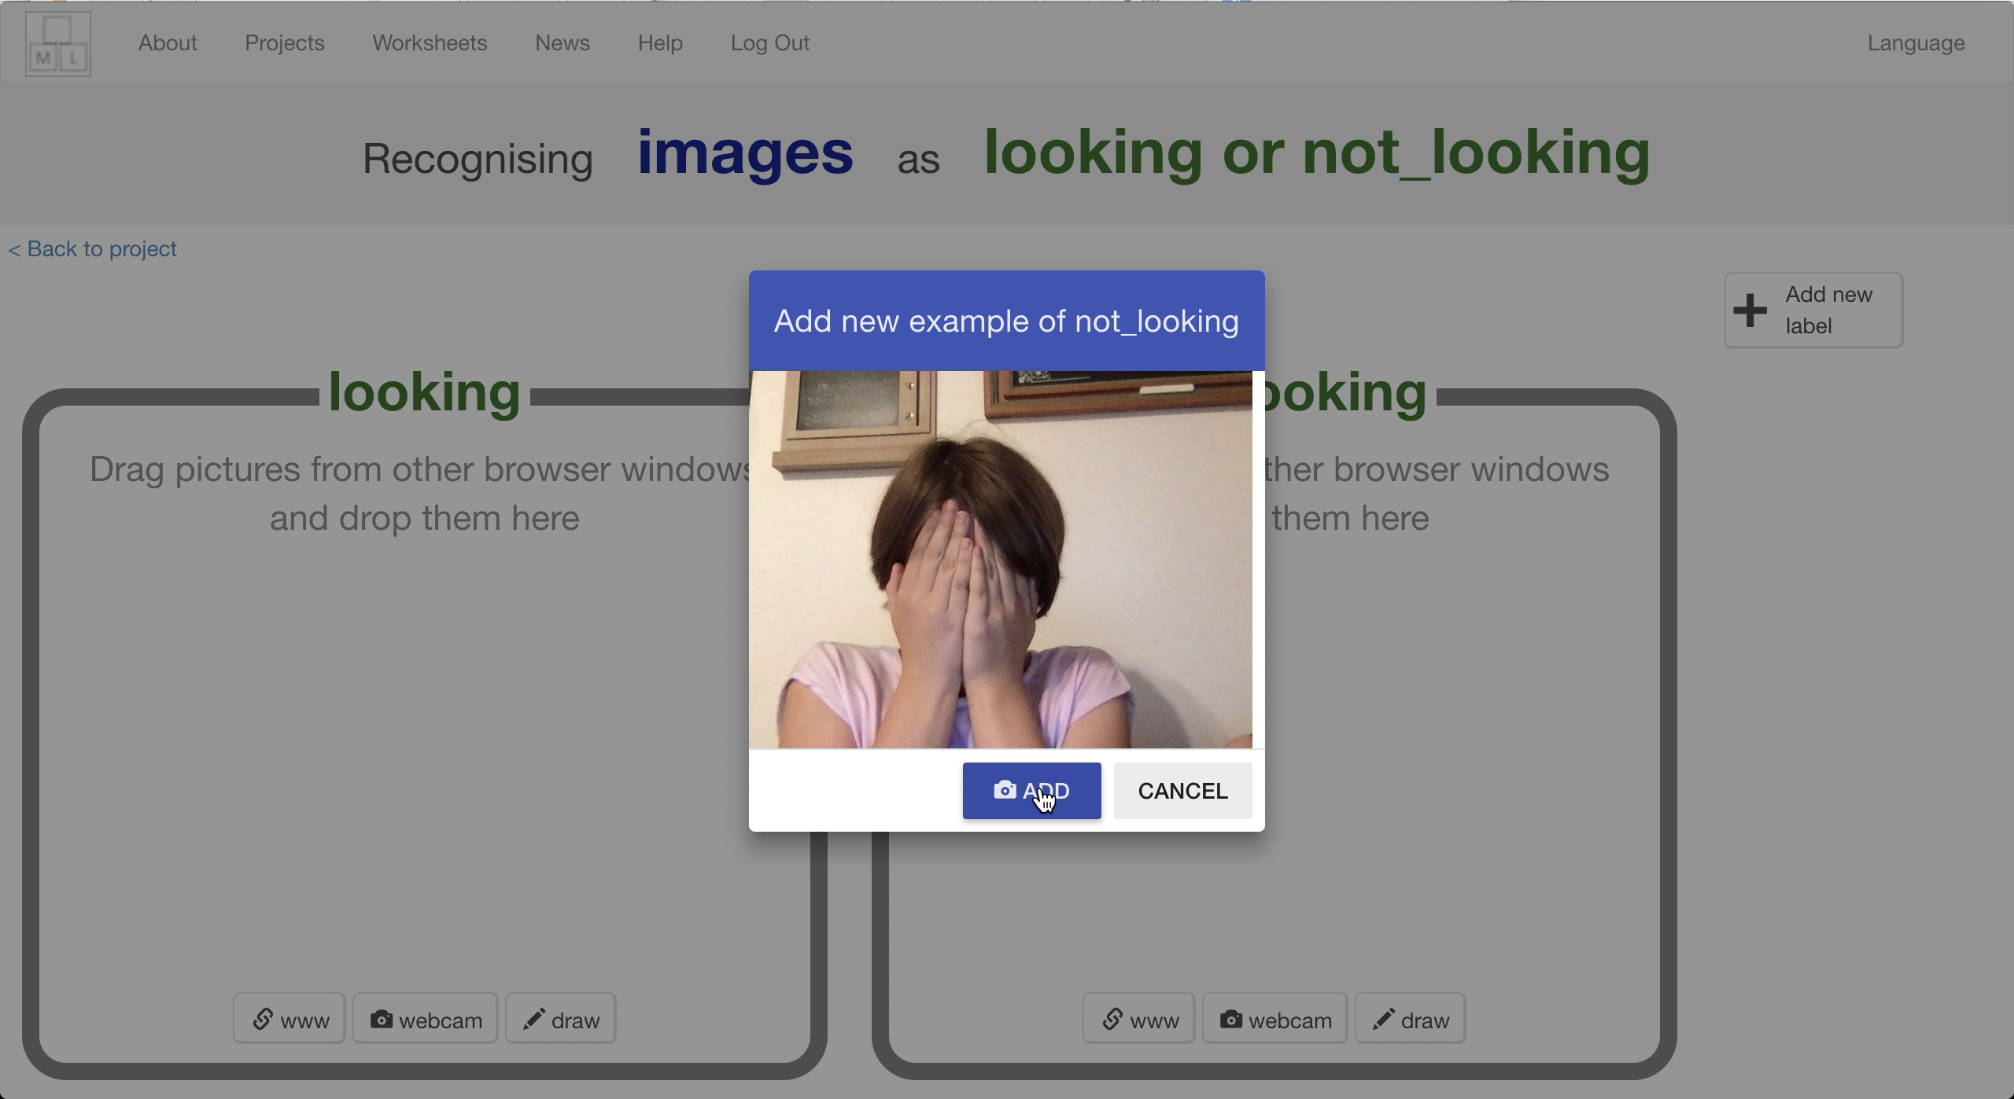
14. Repeat until you’ve got **ten photos** like this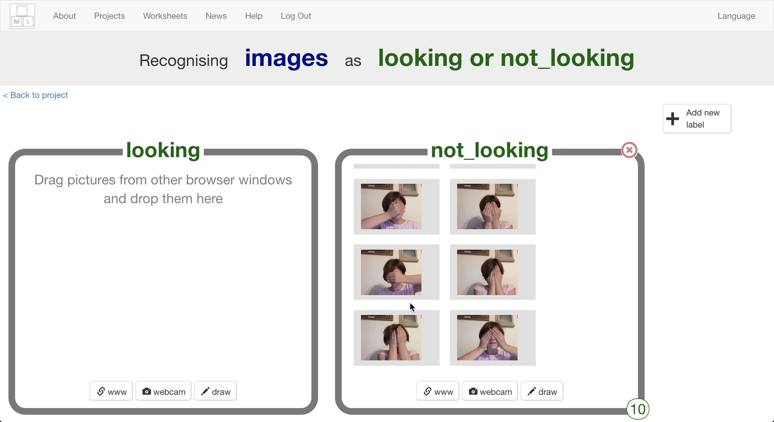
15. Click the “**webcam**” button in the “looking” bucket  
    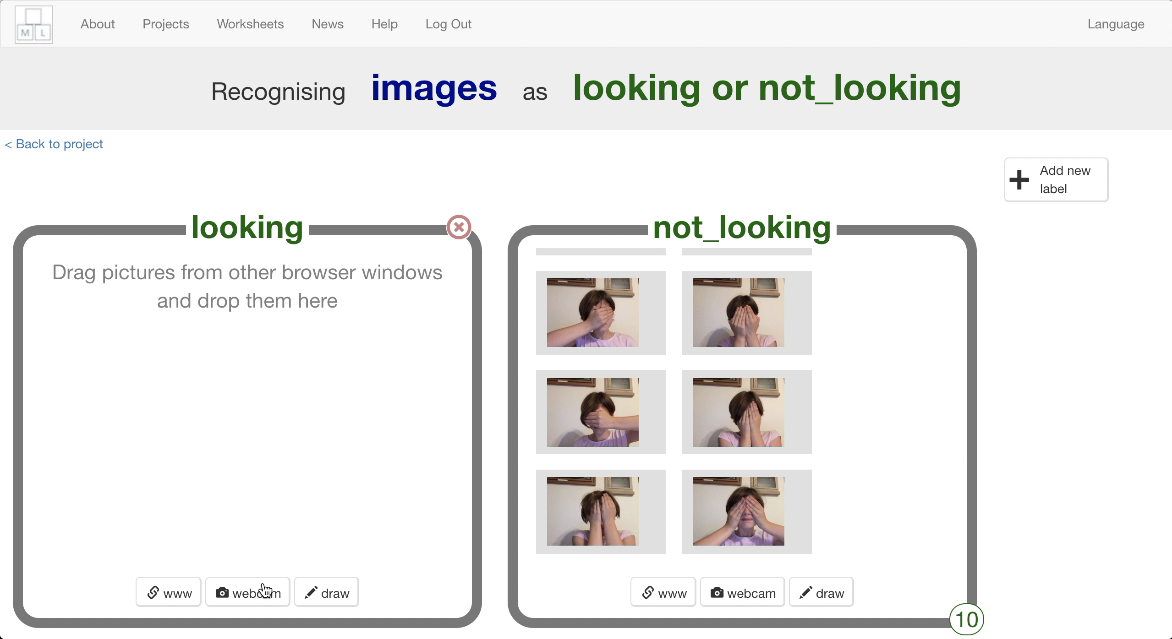
16. Look at the camera and click “**Add**”  
    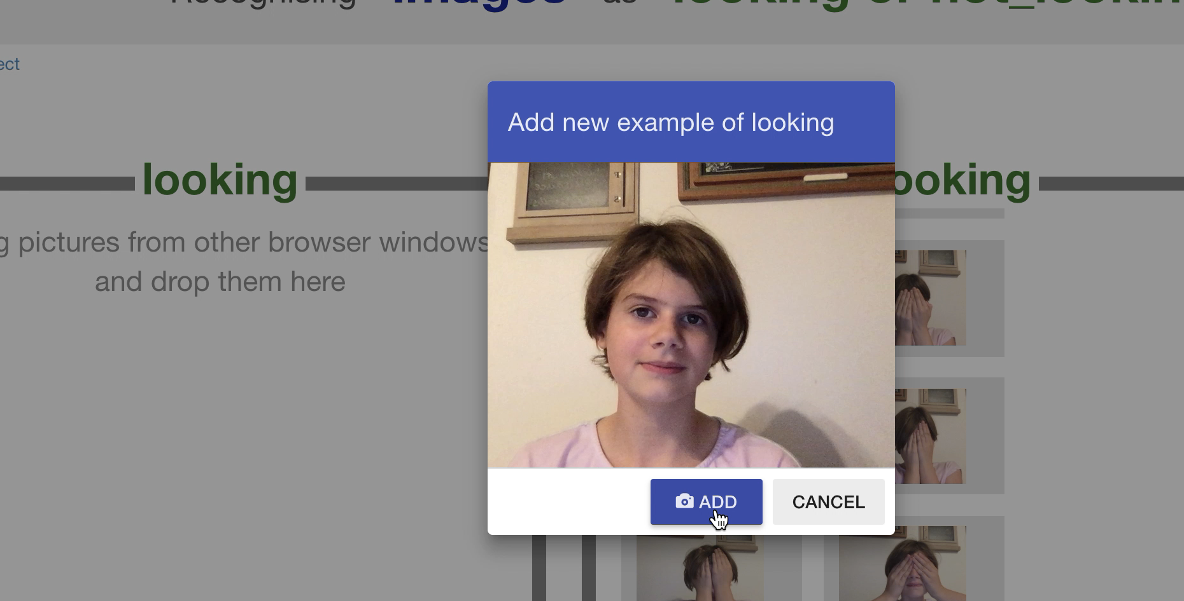
17. Repeat until you’ve got **ten photos** like this  
    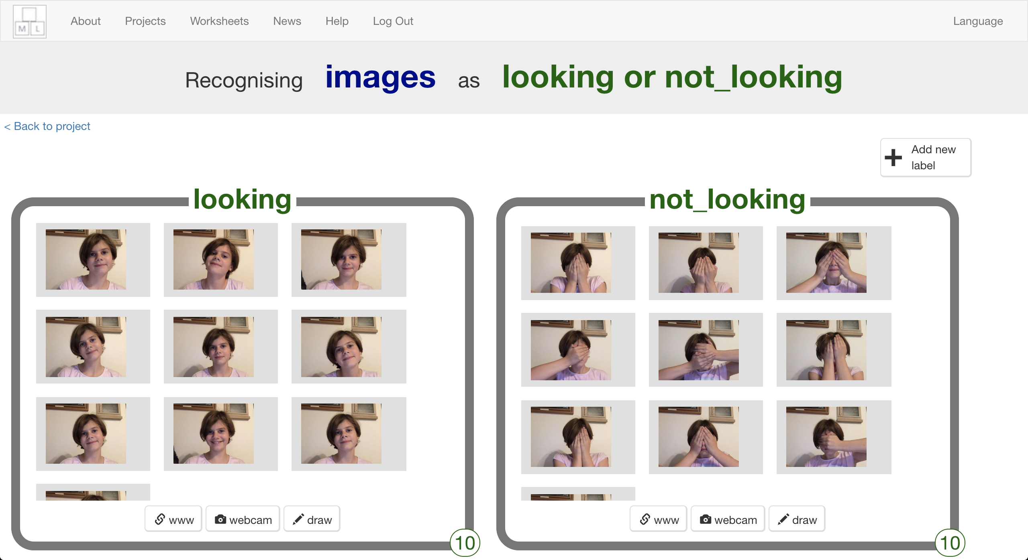
18. Click “**< Back to project**”
19. Click **Learn & Test**
20. Click the “**Train new machine learning model**” button  
    *It might take a few minutes for the model to train.**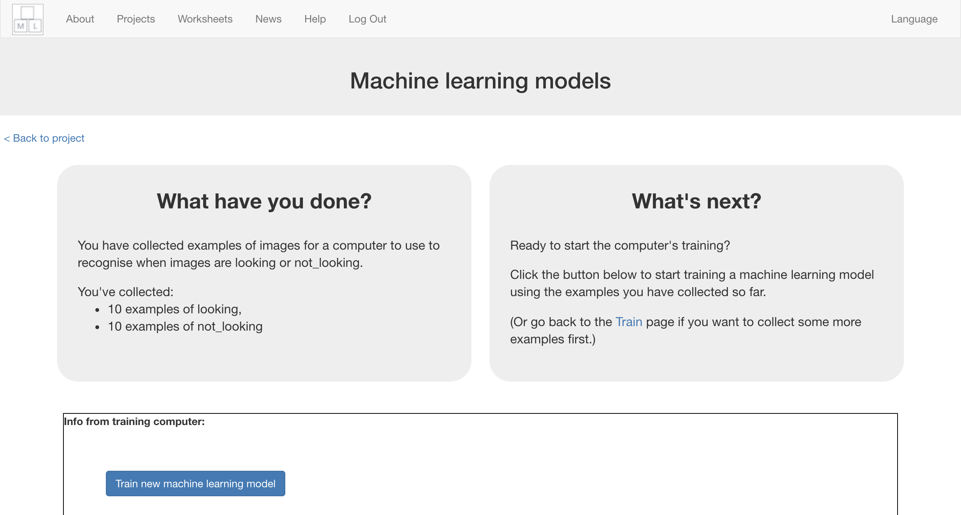*

**What have you done so far?**

You’ve started to train a computer to recognise whether photos of a face and photos of a covered face. You are doing it by taking example photos. These examples are being used to train a machine learning “model”.

This is called “supervised learning” because of the way you are supervising the computer’s training.

The computer will learn from patterns in the shapes from each of the photos you’ve given it. These will be used to recognise new photos.

1. Click “**< Back to project**”
2. Click the “**Make**” button
3. Click “**Scratch 3**”  
   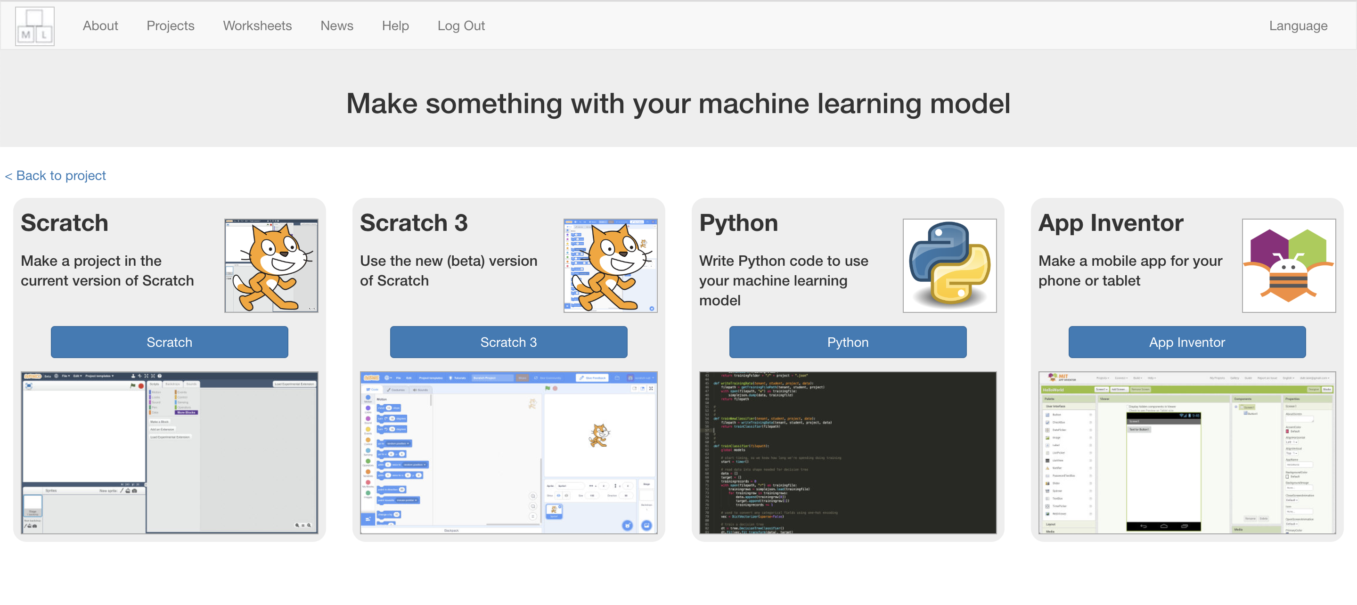
4. Click on “**Open in Scratch 3**”  
   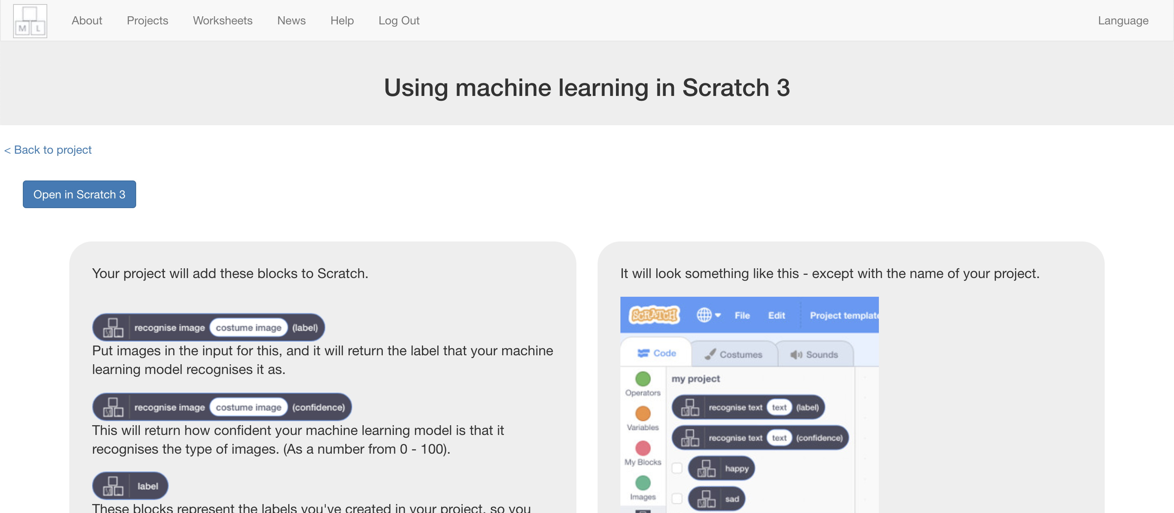
5. Click on “**Try it!**”  
   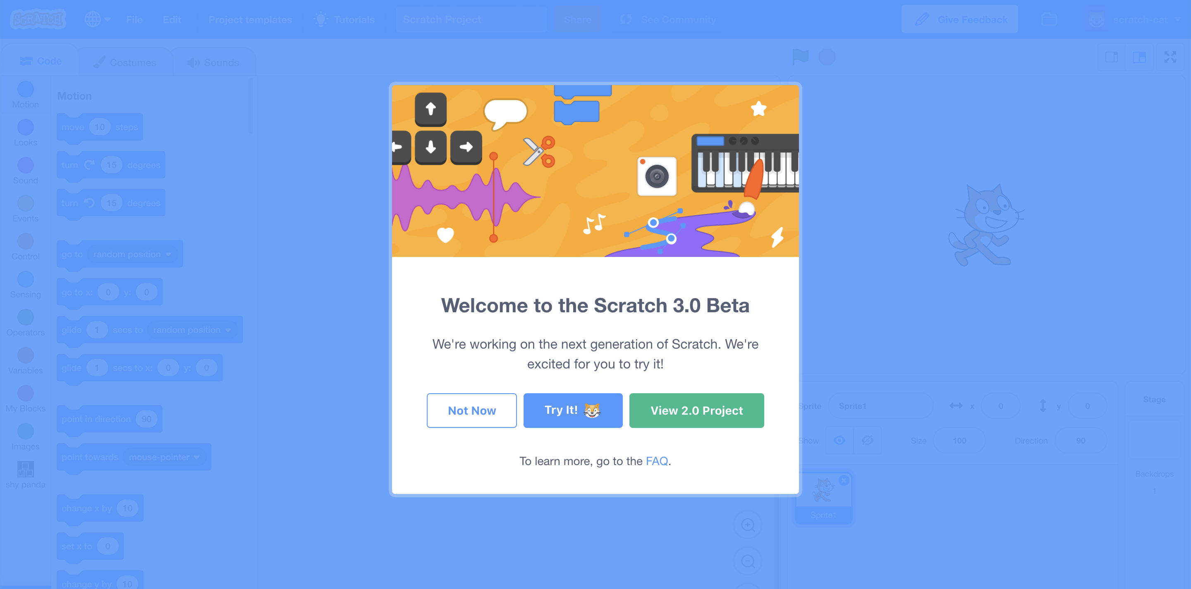
6. Click on “**Project templates**”  
   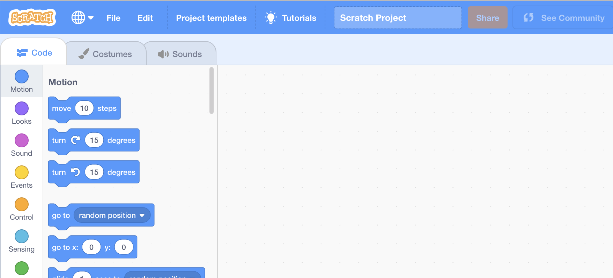
7. Click on the “**Shy Panda**” template  
   *You might need to scroll down to it  
   If your browser asks for permission to use the web-cam, click* ***Allow***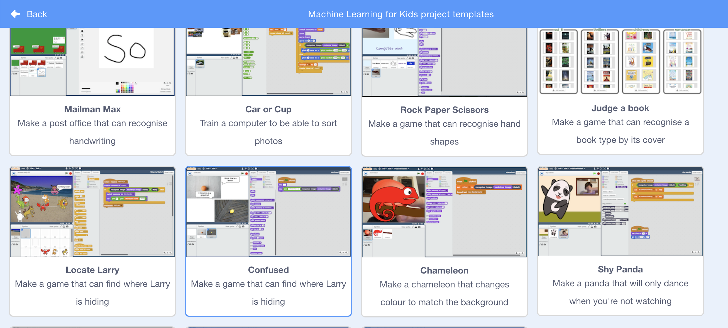
8. Click on the Green Flag to see the panda dance! *Click the* ***red stop button*** *before moving to the next step.*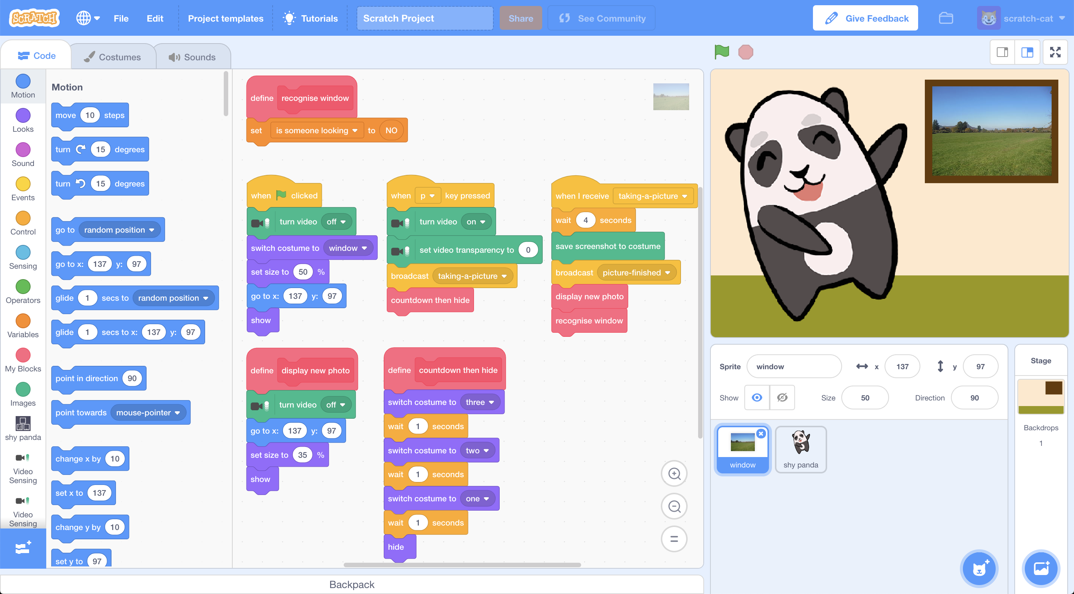
9. Find the “**recognise window**” script in the “**window**” sprite  
   
10. Change the “**recognise window**” script so that it looks like this  
    *If you’re new to Scratch 3, don’t worry as it’s very similar to Scratch 2. Scroll through blocks in the toolbox on the left to find the blocks you need.*   
    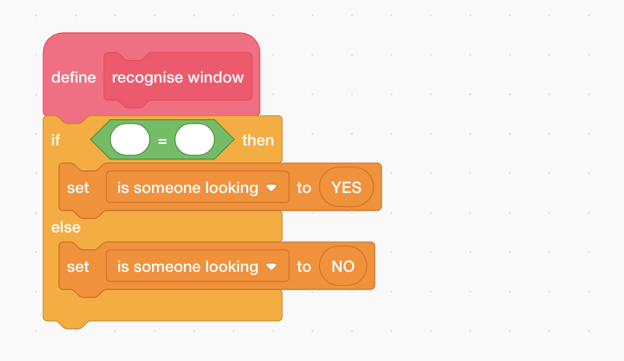
11. Click on “**shy panda**” in the toolbox and then find the   
    “**recognise image** (costume image) **(label)**” block  
    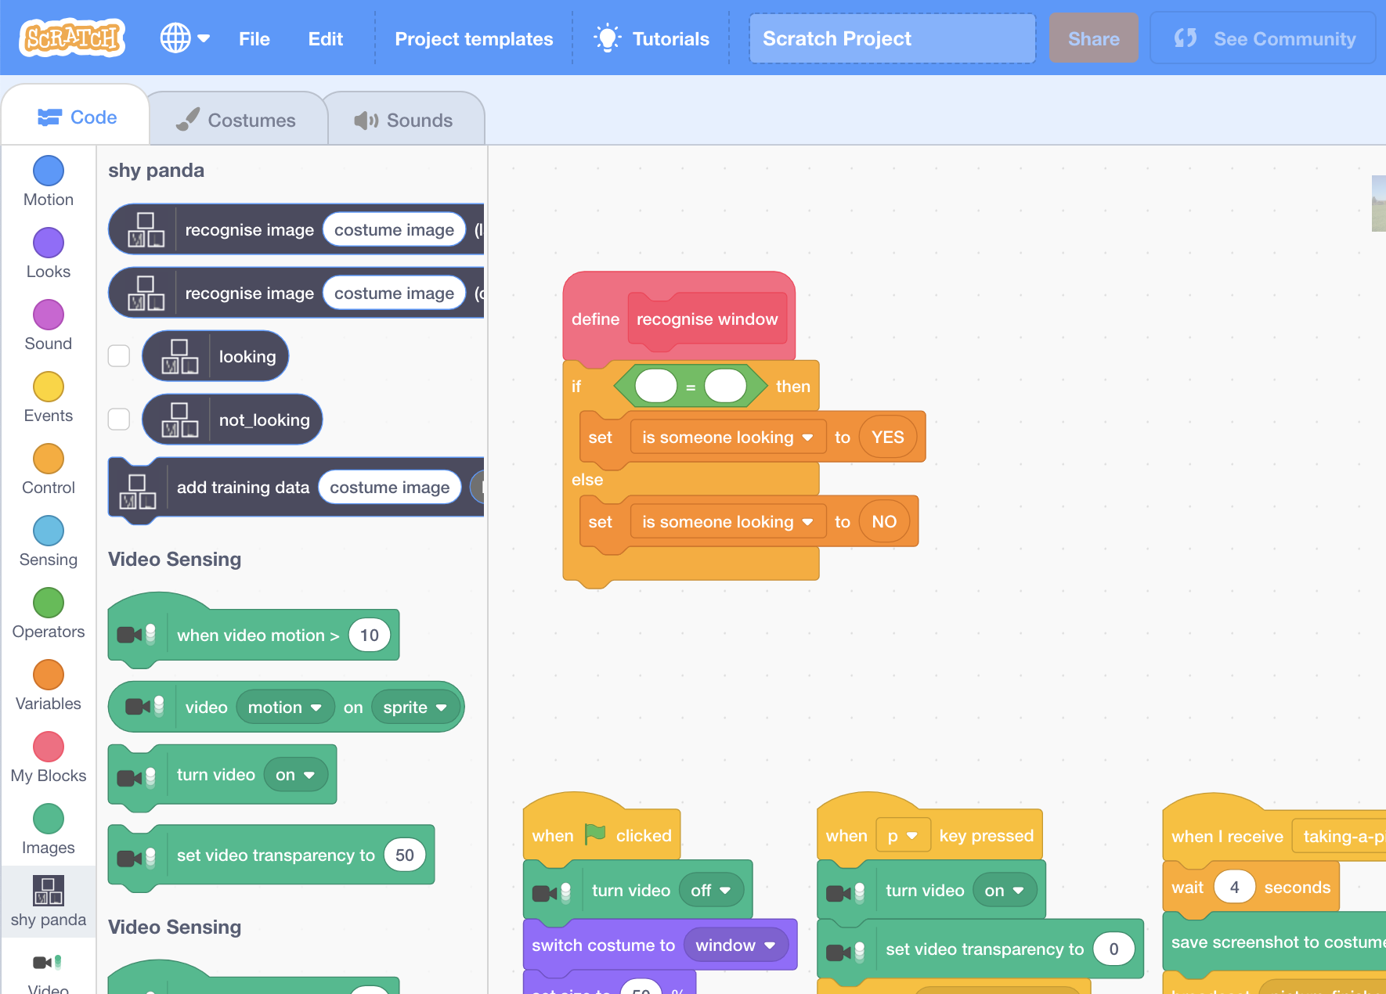
12. Change the “**recognise window**” script using “**shy panda**” blocks  
    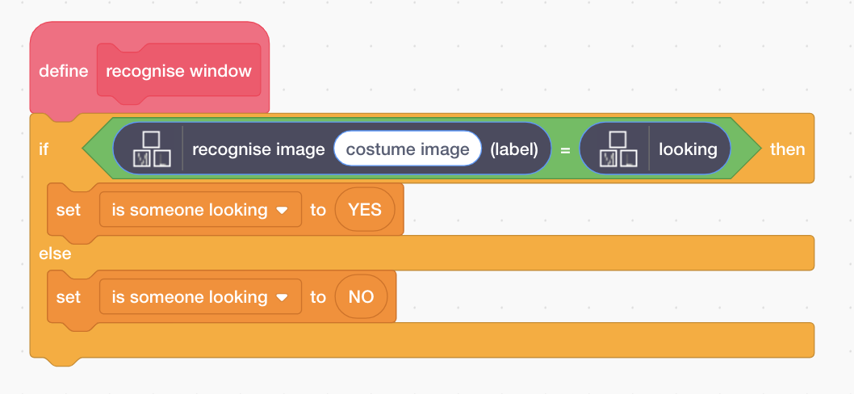
13. Click “**images**” in the toolbox and find the “**costume image**” block  
    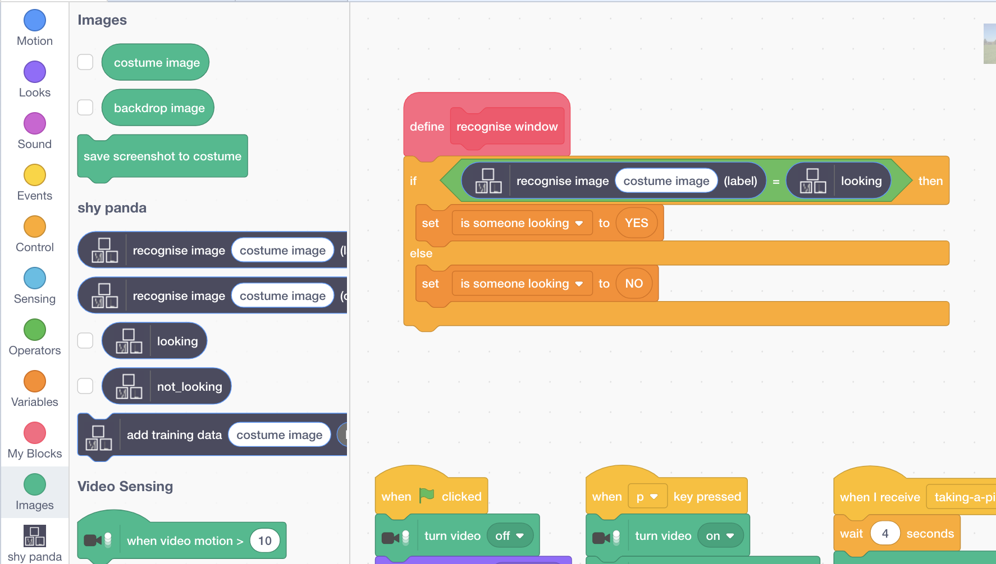
14. Finish the “**recognise window**” script with the costume image block  
    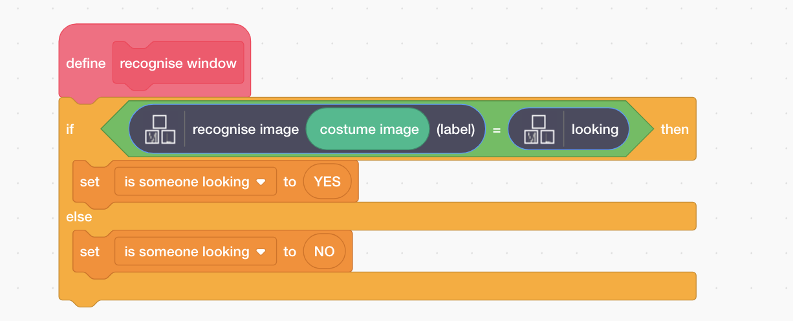
15. Click the **full-screen** button  
    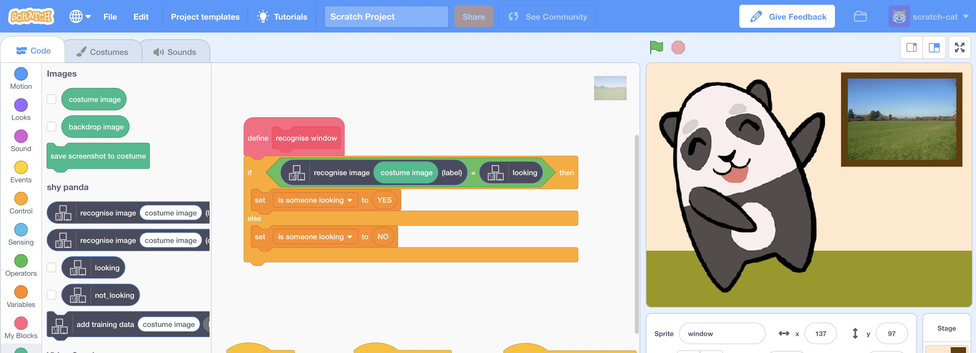
16. Click the **Green Flag** to start the panda dancing again
17. Press “**P**” on your keyboard to take a picture of yourself looking in   
    *You’ll get a 3-second countdown before the photo is taken  
    If your machine learning model recognises the photo as “looking”, the panda should stop dancing and look embarrassed!*

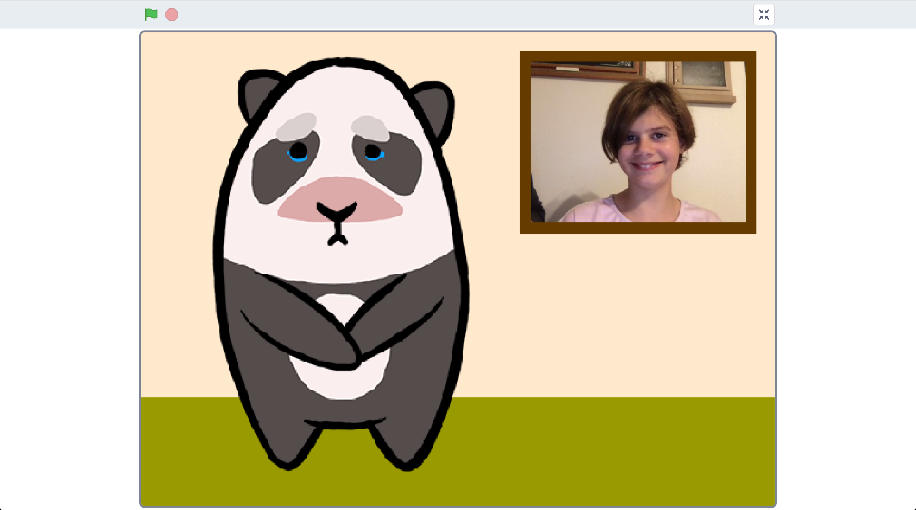

1. Press “**P**” again to take a second photo. This time cover your face.   
   *You’ll get a 3-second countdown before the photo again.*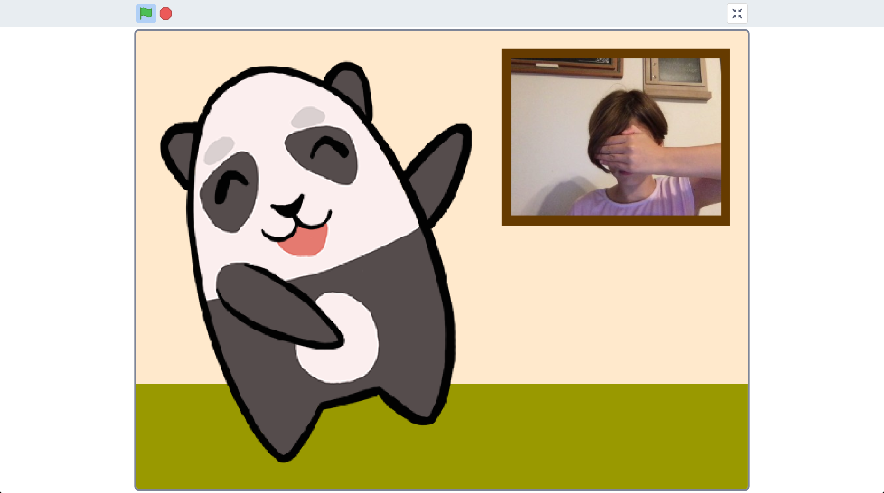
2. The panda should start dancing again, as your machine learning model will recognise that you’re not looking.
3. Save your project  
   *Click the* ***full-screen*** *button again   
   Click “****File****” -> “****Download to your computer****”*

**What have you done?**

You’ve created a shy panda in Scratch that uses machine learning to recognise whether the view at the window is a picture of you looking in.

The machine learning model that you’ve trained is an image classifier, that is able to classify photos as one of two classes – either looking or not looking.

The more examples you give it, the better it should get at recognising whether or not you’re looking at it.

**Ideas and Extensions**

Now that you’ve finished, why not give one of these ideas a try?

Or come up with one of your own?

**Draw your own character**

You don’t have to use the panda in the project template. Why not draw your own character? You’ll need two sprites to be able to animate it dancing, and a third sprite of it looking shy.

**Improving your training**

Try testing it with your classmates. Does the panda still behave correctly?

What about if there’s no one there at all?

How can you improve the training so that the panda does the right thing for these sorts of cases?